Important Points to Note
JIRA is a web application that provides a private website to an individual or a set of requested users belonging to the same company/project.

JIRA can be run as a Windows Service at the server side.

JIRA is a pure Java based application and supports all OS platforms like Windows, Linux of different versions or MAC, etc., those satisfy JDK/JRE requirements.

JIRA supports all famous browsers like Chrome, IE, Mozilla and Safari.

It supports Mobile browsers as well in mobile views.

System Requirements
Since JIRA is a web-application, it follows the concept of client/server. It means that JIRA can be installed centrally on a server and users can interact with it through web-browsers using a website from any computer.
Browser − JavaScript should be enabled, the user is recommended not to use any script-blocking tool like NoScript to access full functionality of JIRA.

JDK/JRE − It is recommended to update JRE/JDK with the latest version. JIRA 6.4 recommends using JRE/JDK version 8.
Since our scope is to consume the JIRA application as end users, we can ignore the server side requirements.

Installation at the Server Side
JIRA follows the Client/Server concept. At the server side, JIRA must be installed before using it as end user.

At the server side, JIRA must connect with relation database to store issues/application data.

Download the JIRA Windows Installer.exe file from the following link − https://www.atlassian.com/software/jira/download?_ga=1.28526460.1787473978.1 488778536.

https://www.google.com/search?q=how+to+download+jira+for+free&oq=how+to+download+jira+tool&aqs=chrome.1.69i57j0i390l4.19058j0j15&sourceid=chrome&ie=UTF-8
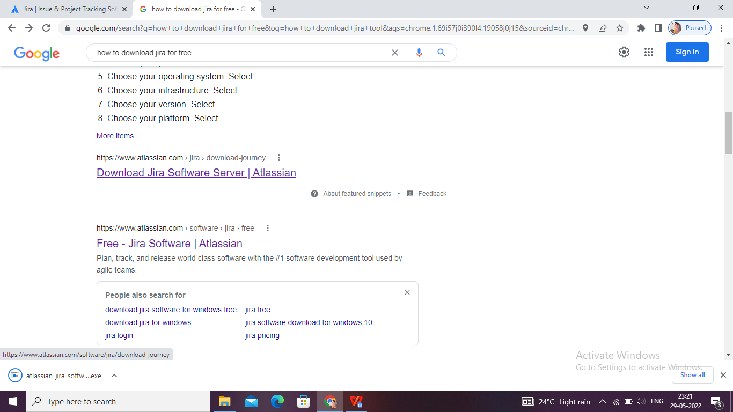

https://www.atlassian.com/software/jira/download-journey
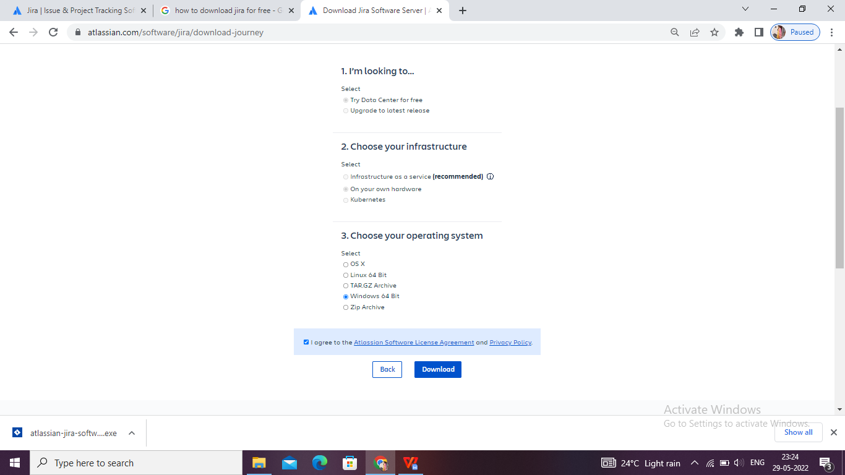

Select the OS type and click on Download.
The following screenshot shows how to download the .exe file for a specific OS.
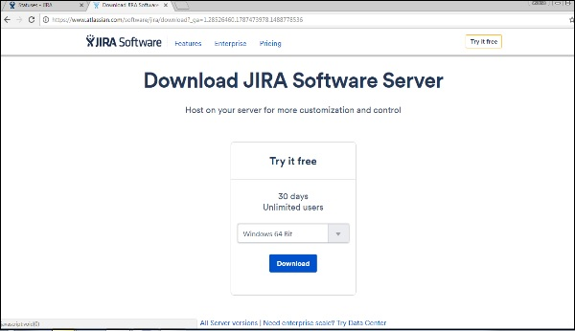
Run the .exe file to run the installation wizard. The following screenshot shows the downloaded .exe file.
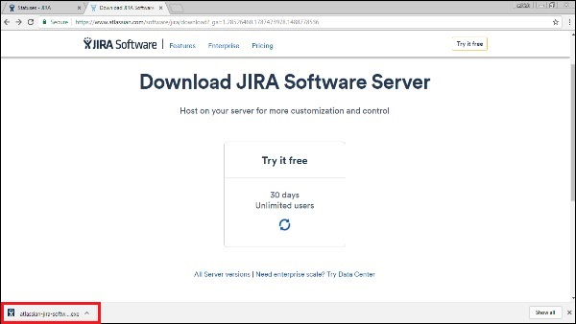
After clicking the .exe file, the Run confirmation pop-up displays, click on RUN. The following screenshot shows the RUN confirmation pop-up.
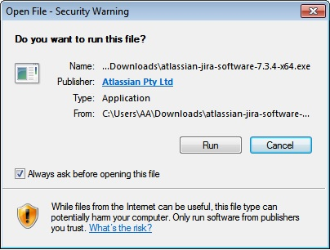
The following JIRA installation wizard displays, click on Next.
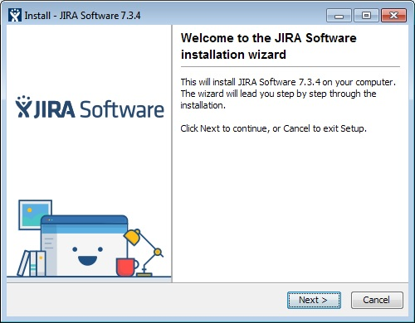
Choose the appropriate installation option as shown in following screenshot and then click on Next.
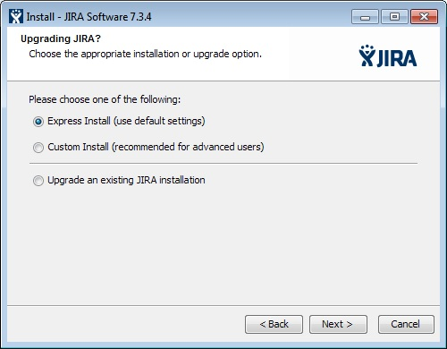
The installation summary is displayed with the Destination Directory, Home Directory, TCP Ports, etc., as shown in the following screenshot.
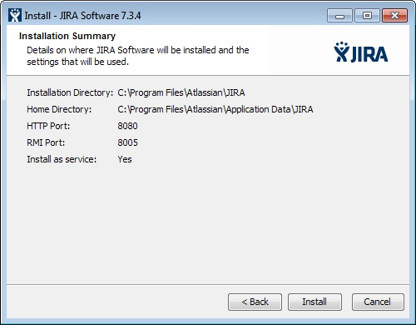
Click on Install. JIRA will start installing as displayed in following screenshot. It takes a couple of minutes to finish the installation.
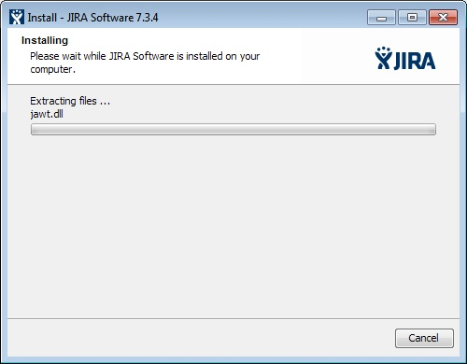
After installation, JIRA will be started automatically if the check box to “Start JIRA Software 7.3.4 now” is checked. Then click on Next, if not, it can be accessed using the appropriate Windows Start Menu shortcut.
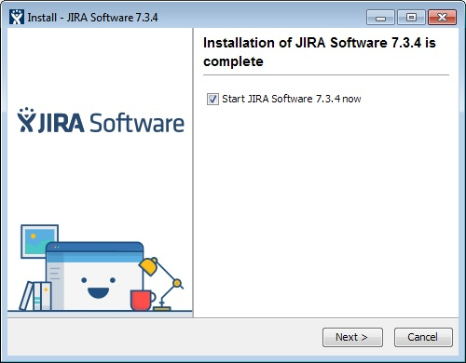
Click the Finish button.
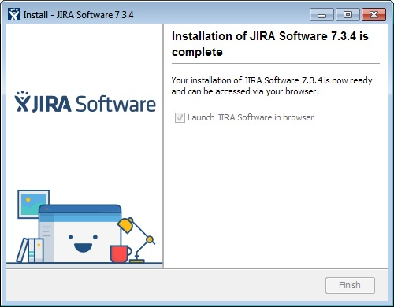
The installer will create the following shortcuts on the start menu −
- Access JIRA
- Start JIRA Server
- Stop JIRA server
- Uninstall JIRA
The following screenshot shows the above-mentioned shortcuts −
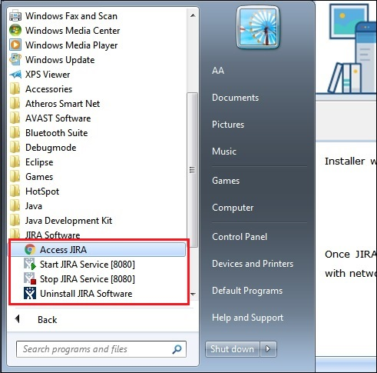
Select the license type and enter organization name as shown in following screenshot −
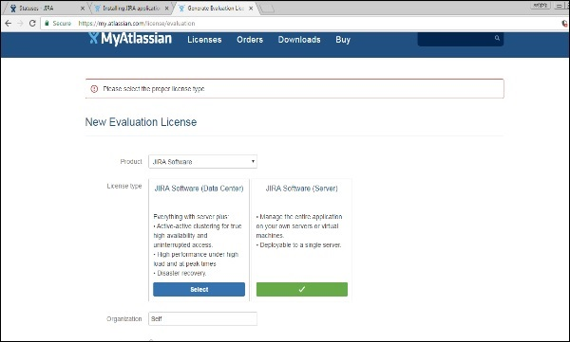
Click on Generate License
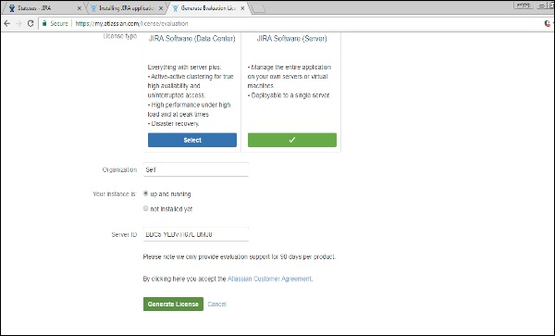
A confirmation pop-up will display as shown in the following screenshot. Click on Yes.
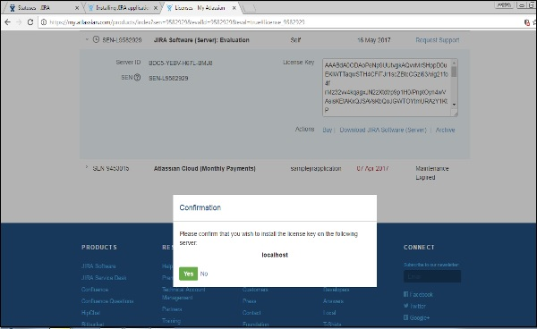
Set up the administration account as displayed in the following screenshot.
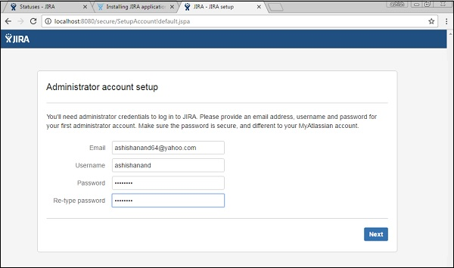
JIRA will automatically finish the setting-up as shown below −
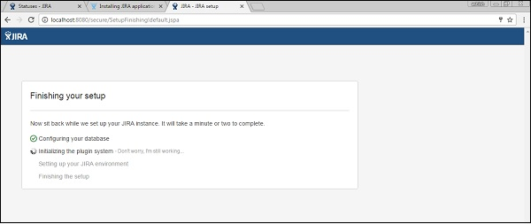
Once JIRA finishes the setup and starts running in the server, the user can access it from a browser on any computer with network access to the JIRA server.
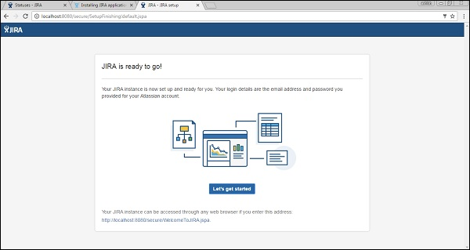

JIRA provides 15 days to 1-month free trials of basic features. JIRA has other plans as well with different advanced features and add-ins. The cost depends on the number of users.
By visiting https://www.atlassian.com/software/jira/try, a user can see different available plans for trying purposes.
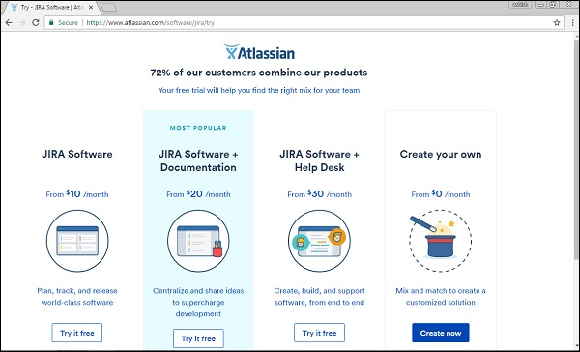

Setup for Free Trials
To setup a free trial, the user has to Sign up on the following link https://id.atlassian.com/signup?application=&tenant=&continue or login if he already has an account.
The following screenshot shows required fields to sign up in Atlassian account.
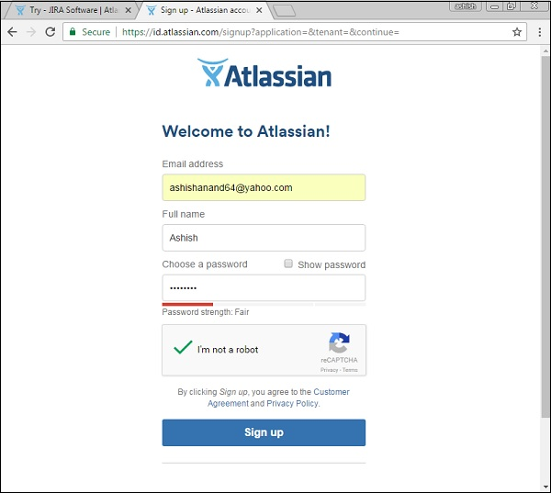
The user has to log into the email account and verifies the account by clicking on the link sent by JIRA-Atlassian. The next step is to go to https://www.atlassian.com/software/jira/try and click on Create now button, which is at the bottom right hand of the webpage.
The following screenshot shows different plans available for trial of JIRA.
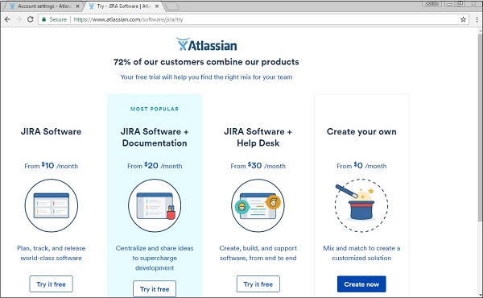
The following screenshot shows the details of the chosen plan for a free trial.
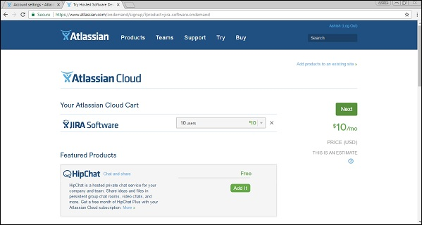
Once the user fills in all the details along with the sample website name, user has to click on the Start now button. The following screenshot shows how to claim your site and provide your credentials to start it.
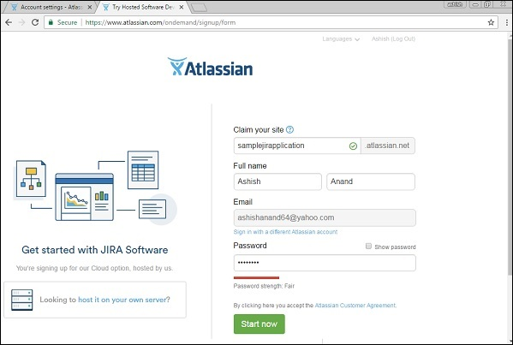
It will take a few minutes to start the requested sample JIRA website. Once it is done, the JIRA login page will display and the user can see the given sample website name in the browser’s address bar. The user can now directly access this link to navigate to JIRA. The following screenshot shows the login page of JIRA.
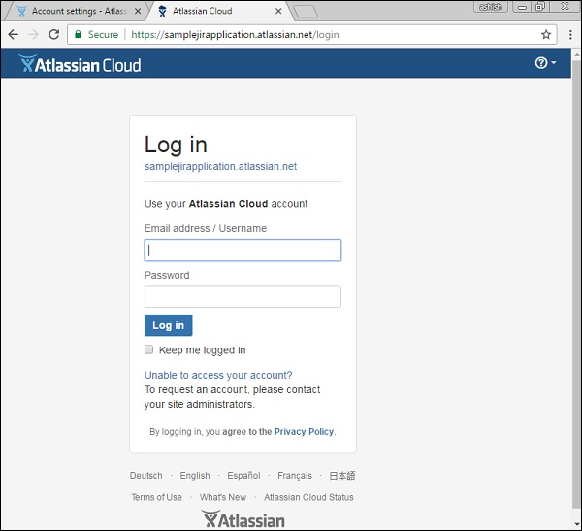
To login to JIRA, go to your sample website. It will open a login page. Fill in your registered email address/username and Password. Click on the Login button. The following screenshot shows how to login into JIRA using your credentials.
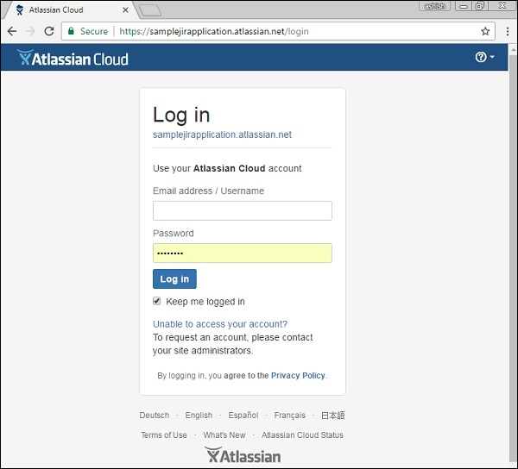

Common Login Errors
In case of any unsuccessful login, an error message displays. The following screenshot shows the error message a user receives, if the credentials are not matching or incorrect.
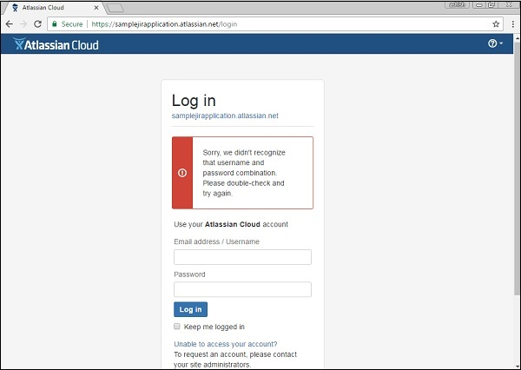
To rectify this scenario, click on “Unable to access your account”, then select the appropriate option and fill in the details. Click on email. The following screenshot shows how to recover the username, in case the user has forgotten it.
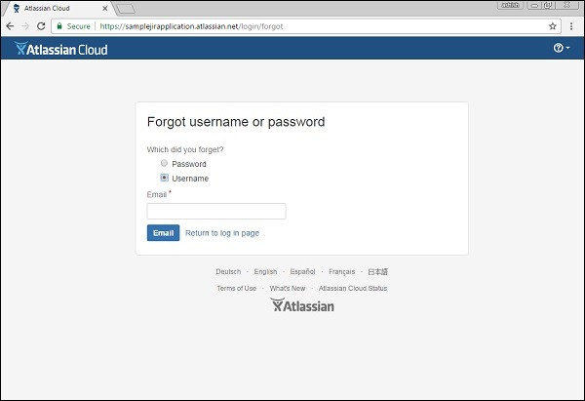
The user will get an email with the details of his username or a link to reset the password.

Successful Login
On a successful login, the system dashboard will display if the account is associated with any project by the admin, or if a user can create a sample project as explained in the earlier chapters.
The following screenshot displays the welcome page/dashboard of JIRA on a successful login.
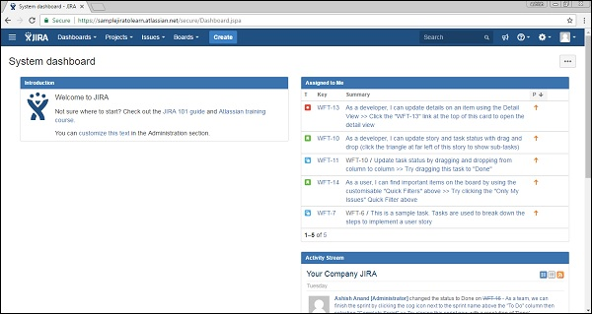
After logging into JIRA, the Dashboard is the first page that shows up. The Dashboard is customized by the Admin. Based on the roles, the admin can set the access of JIRA. Even the admin has the right to change colors and the logo of JIRA.

Important Points of the Dashboard
Following are some of the most significant points the users should understand before using the JIRA Dashboard −
The navigation bar, present at the top of the JIRA page, will be the same across all the pages/screens of JIRA. Dashboard, Projects, Issues, Boards and Create are the main links. These links have many sub-links to navigate other functionalities.
Navigation bar contains links that provides a quick access to the most useful functions of JIRA.
Just under navigation bar, there is a System Dashboard.
The information provided in the system dashboard area can be customized by the Admin.

By default, it has three main sections – Introduction, Assigned to Me (displays Issues list assigned to users) and Activity Stream (Activities done by the users).

The following screenshot shows the overview of the Dashboard page of JIRA −
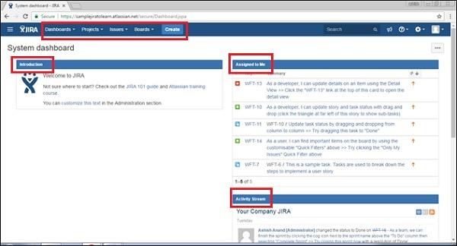

Types of Projects
The Projects link has several sub-links, which are explained in detail for better understanding −
Current Project − It displays the name of the Project where the user is currently in or is viewing the dashboard of the project. By clicking at Project name, it will display the list of issues associated with the project.

Recent Project − It displays the name of the recent project that the user has accessed, if exists, where the user can navigate by clicking on the project listed under this header.

Software − It is the sub-link to navigate the list of projects, which are listed in the Project Type as Software.

Business − It is also a project-type. By clicking here, it will display the list of business project types.

View all Projects − It displays all the projects, which are associated with the logged in user.

Create Project − This link is usually accessed by the Admin or it depends on various roles. If this link is visible, a user can create a new project by following the instructions given there.

The following screenshot shows the different sub-links under the Project category.
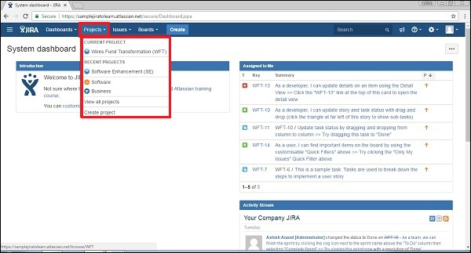

Types of Issues
It has many sub links to access other functionalities. The following screenshot shows different available sub-links under Issue navigation.
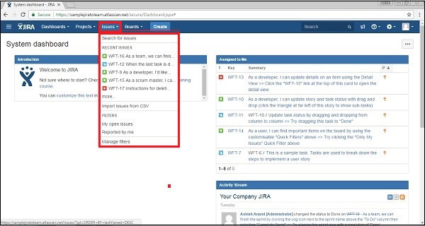

Search for Issues − It navigates to the search page, where the user can provide search criteria to narrow down the results.
Recent Issues − It displays the list of issues that are recently viewed by the user.
Import issue from CSV − This feature allows the user to import the details of issues by uploading a CSV file and mapping the fields.
My open issues − It is the filter section, which displays issues those are open and assigned to the logged-in user.
Reported by me − This filter section displays the issues, which are already created by the logged-in user.
Manage filters − It helps to customize the filter and narrow down the results. It displays any saved filters/ favorites filters.

Types of Boards
Boards are showcase of process that is followed by Project. It could be the most famous Agile Board if the project is following the agile methodology or it might be the Kanban board as well.

Recent Board − It displays the recent project board accessed by the user.

View all boards − It displays all available project boards.

The following screenshot shows the different sub-links available under the board section.
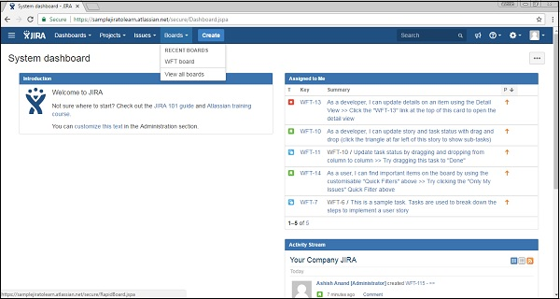

The Create Button
By clicking on the Create button, it displays the create form to log an issue.
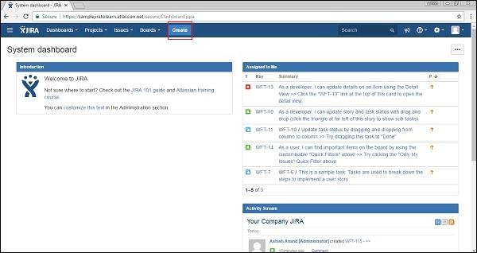
The following screenshot shows required fields and other fields to create an issue −
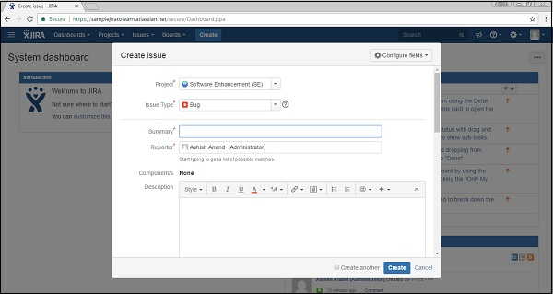

The Feedback Link
There is a feedback link at the right side of the navigation bar (as highlighted in the following screenshot). By clicking on link, user gets a form where he can provide feedback by entering Summary, Description, Name and email.
The following screenshot shows the location of the Feedback link present in the Dashboard.
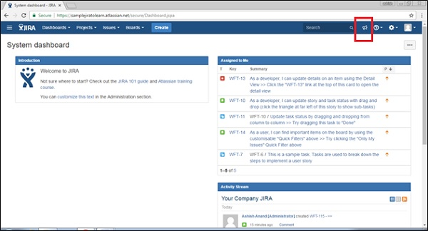
The following screenshot shows the required and optional fields to provide feedback.
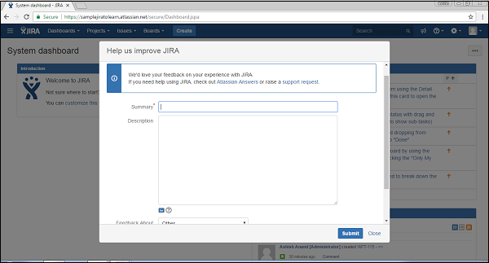
Once all the fields are filled, click on Submit, it successfully posts the feedback.

The Help Link
The Help link provides different useful documentation about JIRA. It provides the details of JIRA as well by clicking on “About JIRA”. Similarly, this link also provides new release features by clicking on “What’s new”. Keyboard shortcuts have much useful keyboard navigation for users that saves time. The following screenshot shows the Help link and different sub-links available in it.
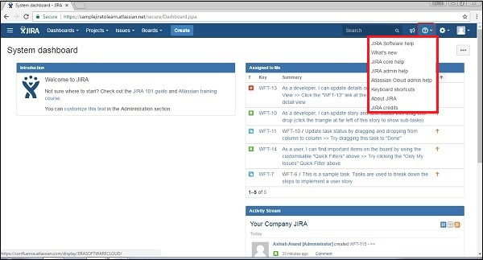

User Profile Button
By clicking on the profile link, the user can view his profile details and manage this section. By clicking on Logout, the user will get back to the login page and will not be able to access the project details without logging in again.
The following screenshot shows available functionality under User-Profile section −
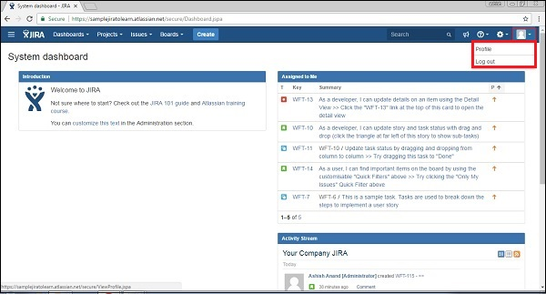
By clicking on the edit symbol, the user will be able to edit profile details like – Summary Details, Preferences, etc. The following screenshot shows how to edit the profile by clicking on the Edit (highlighted in red outline) icon at each section.
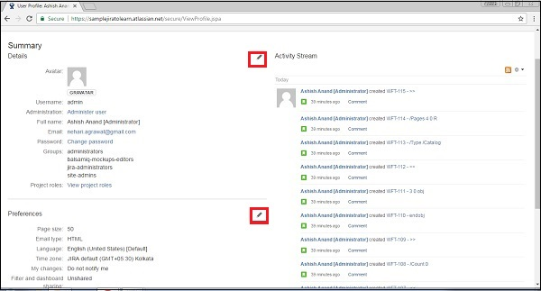
On the right side, the user can see the activity stream performed by the logged in user.

